Table of Contents
Introducing the tool 2
Who is this tool for? 2
What is the purpose of the tool? 2
How can the tool benefit countries? 2
How should countries complete the tool? 2
Who should coordinate the process? 3
Who should be involved in the process? 3
When should the tool be completed? 3
Guidance on using the tool 6
How does this tool connect to the Global Partnership for Action to Eliminate all Forms of HIV-Related Stigma and Discrimination? 6
How does this tool connect to the Global Fund’s investment, including the Breaking Down Barriers (BDB) initiative? 6
Can any country use the tool? 7
What does this tool not cover? 7
Is this a requirement for donors or UN agencies? 7
Where do we submit the completed tool or report? 7
How much time should we allocate? 8
What resources will we need? 8
What does the desk review involve? 8
Template: Desk review report 9



Introducing the tool

This tool was developed by IAS – the International AIDS Society, in consultation with national and global stakeholders.

Who is this tool for?
This tool is for national stakeholders working to reduce HIV-related stigma and discrimination, including representatives of various ministries of government, community-led organizations, civil society organizations, development partners, donors and researchers.

What is the purpose of the tool?
The purpose of the tool is:
- To facilitate self-reflection among national stakeholders and review how the country is performing on initiatives to reduce HIV-related stigma and discrimination
- To build consensus on priority actions for national stakeholders to take forward in the coming year and inform strategic plans, budgets and funding proposals
- To steer progress on the country’s efforts to reduce HIV-related stigma and discrimination

How can the tool benefit countries?
The tool can support countries that want to accelerate progress on reducing HIV-related stigma and discrimination. Using the tool:
- Ensures better coordination among key national stakeholders
- Uses existing data to develop shared analysis among the stakeholders
- Facilitates discussion on how to address the most critical challenges and improve the quality of interventions
- Prioritizes areas for action, learning and investment

How should countries complete the tool?
The tool is an Excel file that should be completed through a consultative process at a workshop with all key national stakeholders working on HIV-related stigma and discrimination. The Excel file has four sections or tabs that should be completed. The tool offers guidance throughout.

Who should coordinate the process?
In many countries, this tool would be best completed at a workshop or an extended meeting of the country’s Human Rights or Stigma and Discrimination Technical Working Group (HR TWG) or a similar multi-stakeholder body. Organizations that work on reducing HIV-related stigma and discrimination, but are not members of the HR TWG, should also be invited to the workshop. Ideally, the workshop and the overall process should be jointly chaired by a government representative and a representative of a relevant community-led organization (that is, a network of women, young people or people living with HIV or a key population organization).

Who should be involved in the process?
The process should involve relevant stakeholders from various ministries of government, research organizations, technical and development partners, donors and civil society. Community-led organizations, including networks of people living with HIV and key populations, are at the forefront of efforts to address HIV-related stigma and discrimination. It is critical for all community-led organizations working on stigma and discrimination to be meaningfully involved in this process.

Based on the likely priority focus areas, stakeholders with relevant expertise or knowledge should be invited. For example, invite a representative of a police association if the focus is addressing harassment of sex workers by the police force, or invite someone who is responsible for developing the content for training healthcare workers if the focus is reducing stigma and discrimination in healthcare settings.

When should the tool be completed?
The tool should be completed annually to guide workplans and budgets and set priorities for funding and/or technical needs.

Countries should plan to use the tool at a time that aligns with related national processes, such as the national budget cycle, funding proposals for donors, and national strategic planning.

For countries that are part of the Global Fund’s Breaking Down Barriers (BDB) initiative, it is advisable to closely coordinate the completion of the tool with the BDB self-assessment process, which will be conducted in the final quarter of each year.

How the tool fits the bigger picture…

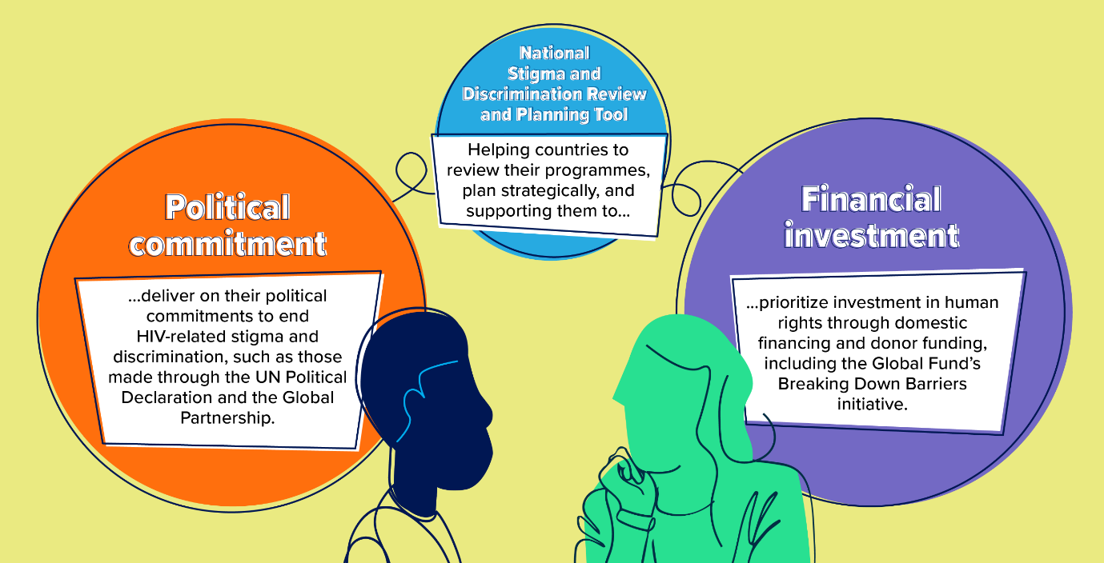

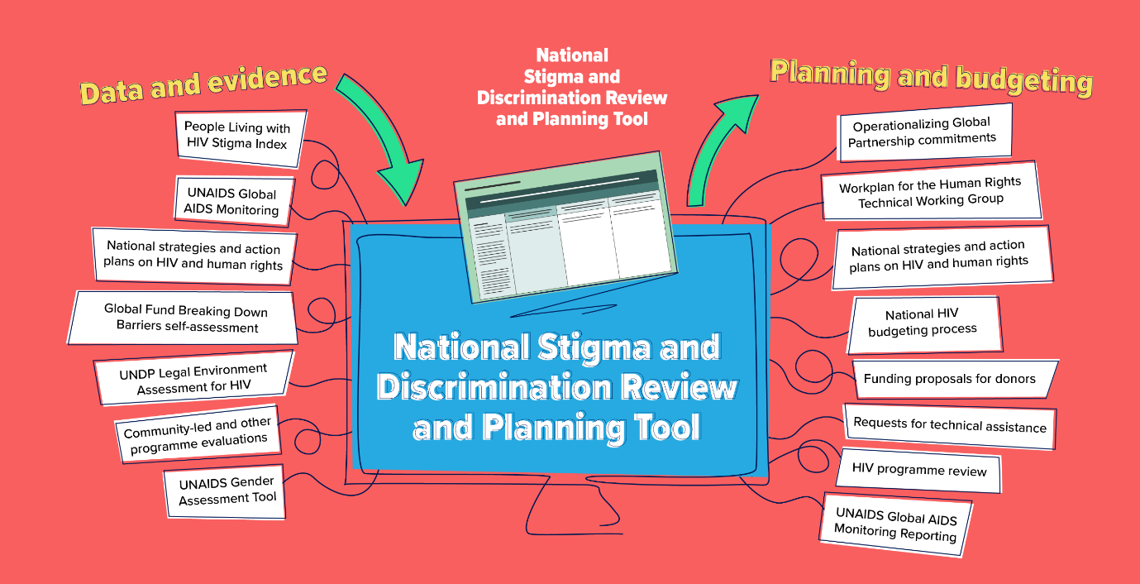

Key Steps: Understanding the process…

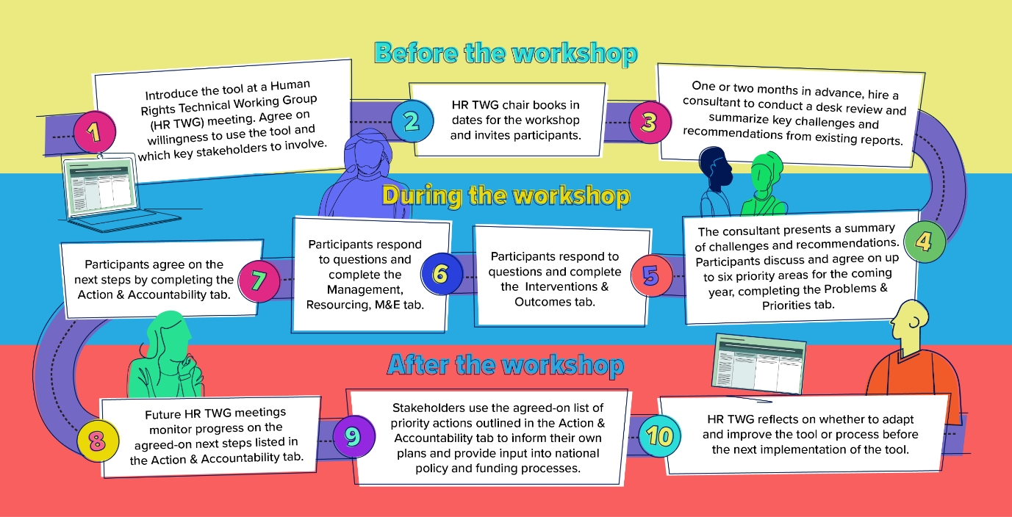

Guidance on using the tool

This tool, and the guidance that accompanies it, is intended to support countries to accelerate progress on reducing HIV-related stigma and discrimination. There are no rigid guidelines for how the tool should be used or the steps to follow. Countries are free to use and adapt the tool in any way that best suits their needs.

How does this tool connect to the Global Partnership for Action to Eliminate all Forms of HIV-Related Stigma and Discrimination?
The Global Partnership aims to translate commitments to end HIV-related stigma and discrimination into action across six different settings. In countries that have joined the Global Partnership, this tool can help national stakeholders accelerate their progress towards reducing HIV-related stigma and discrimination and meet their political commitments by supporting them to assess, prioritize and plan work across their chosen settings.

How does this tool connect to the Global Fund’s investment, including the Breaking Down Barriers (BDB) initiative?
The BDB initiative provides catalytic matching funds and technical support to help countries confront human rights-related barriers to HIV, tuberculosis (TB) and malaria services. All countries that receive a Global Fund grant are expected to monitor their achievements using the Global Fund scorecard, and BDB countries are also asked to conduct yearly self-assessments of progress. These Global Fund self-assessments focus on the scale and coverage of human rights interventions, including those to reduce stigma and discrimination relating to HIV, TB or malaria. This tool focuses solely on HIV-related stigma and discrimination and helps countries assess the quality and outcomes of programmes. The two self-assessments are complementary. The Human Rights Technical Working Group (HR TWG) will lead both self-assessments and should ensure close coordination between both processes.

Can any country use the tool?
"The tool is designed to be used by any country that is interested in reviewing and improving interventions to reduce HIV-related stigma and discrimination. It is particularly for countries that:
a) Have made a strong political commitment to reducing stigma – for example, are members of the Global Partnership and/or have national targets and strategic plans on stigma and discrimination
b) Value the expertise of community-led organizations and meaningfully engage with and provide funding for them – for example, by supporting People Living with HIV Stigma Index research and community-led programmes, advocacy and monitoring
c) Invest in addressing structural barriers – for example, by allocating domestic resources and/or prioritizing this area in funding proposals to donors such as the Global Fund "

What does this tool not cover?
The tool does not map programmes or initiatives to reduce HIV-related stigma and discrimination. While it reviews programme outcomes, it does not include a focus on the scale and coverage of these programmes – this is to avoid duplication with the self-assessment undertaken for the Global Fund. The tool is not designed to track budget allocations or provide costing for interventions. The tool is also solely focused on HIV and does not include other diseases, like TB. However, countries can adapt the tool if they wish to.

Is this a requirement for donors or UN agencies?
The use of this tool is entirely voluntary. Any country that wishes to openly assess the progress it is making to reduce HIV-related stigma and discrimination can benefit from using the tool.

Where do we submit the completed tool or report?
Each country can decide how to use the results. Stakeholders may wish to use the completed tool for national planning, to advocate for funding or technical assistance, to share their progress, or to inform a learning agenda.

How much time should we allocate?
This will vary from country to country depending on the time and resources you wish to allocate. Ideally, you should plan a workshop over 2-3 days to complete the tool fully. If you choose to connect this to other planning or monitoring processes (such as the BDB self-assessment process), you may need to adjust the time devoted accordingly.

What resources will we need?
You will need a budget to cover the following expenses:
- A fee to cover 2-3 days of a consultant’s time to carry out a desk review prior to the meeting and present a summary at the workshop. If funds are limited this work could be done by a member of the HR TWG.
- Venue for the workshop (this could be provided free by a partner)
- Lunch and refreshments
- Stipends to cover any travel expenses, especially for community members of the HR TWG
- A fee for a facilitator for the workshop. Having a dedicated facilitator is advisable to help keep the conversations focused. The facilitator could be the consultant who conducts the desk review or a staff member of one of the partners.

What does the desk review involve?
Before the workshop, a consultant should conduct a desk review of the most relevant and up-to-date national evidence on HIV-related stigma and discrimination. This should be someone who is familiar with the work of the HR TWG and, if the is part of the BDB initiative, the same consultant working on the BDB assessments. They should compile this in a short report and use this to complete the first part of the Problems & Priorities tab on the tool focusing on the biggest challenges and the relevant recommendations. They should present the summary findings at the start of the workshop.

Sources for the desk review include the latest National Strategy, National Action Plan, data from population-based surveys like DHS and IBSS, People Living with HIV Stigma Index report, UNAIDS GAM stigma indicators and NCPI report, UNDP Legal Environment Assessment for HIV, UNAIDS Gender Assessment, Global Fund Breaking Down Barriers assessment and any other reports on HIV-related stigma and discrimination. See next page for a template for the desk review report for the consultant to adapt and use.

Template: Desk review report
This is a suggested outline for a short report (up to six pages) that shares the analysis from a desk review. The report should be completed and shared with stakeholders before the workshop. The consultant will then present a summary at the start of the workshop through a PowerPoint presentation that focuses on sections 1 and 3 below.

1. Overview of some key data points for your country
Provide a brief overview of some of the quantitative data from most recent surveys and assessments, such as IBBS, DHSS, GAM and People Living with HIV Stigma Index. Who is most impacted, in what settings and in which regions? What type of stigma are they experiencing?

2. Latest evidence from key documents
This list is just a starting point. Please select the most relevant reports and documents available in your country for your analysis.

Summarize the biggest challenges according to each of these documents. Be specific: who is most impacted, in what settings and regions, and what type of stigma are they experiencing (internalized, anticipated or enacted)? | Recommendations from each document to address these challenges
National Strategy/Action Plan [insert dates]
People Living with HIV Stigma Index [insert dates]
UNAIDS GAM narrative and NCPI section [insert dates]
Global Fund BDB assessment/scorecard [insert dates]
UNDP Legal Environment Assessment for HIV [insert dates]
UNAIDS Gender Assessment [insert dates]
Community-led human rights reports [insert dates]
Any other

3. Summarizing all the evidence for the tool
Drawing on the review and analysis of the key data and evidence above, present an overall summary here. This is the section that will be used in the tool itself and will inform the setting of priorities and reviewing of programmes and interventions.

Summary of the biggest challenges: Who is most impacted and in what settings? | Recommendations to address these challenges
- xx
- xx
- xx
- xx
- xx
- xx

4. Annex
Add a list of documents reviewed with links.

